**Spesifikasi Kemasan**

**Nama Produk :** ZOI Faraday Series Ceiling Pendant Electric & Electromagnetic Single

Arm For Anesthesia

**Tipe :** ZOI-CP-FEM-1101

1. **Label**
   1. Label penandaan ZOI Faraday Series Ceiling Pendant Electric & Electromagnetic Single Arm For Anesthesia

* Bahan : Stiker Vinyl
* Warna Label : Putih
* Warna Teks : Hitam
* Ukuran : 90 x 60 mm (p x l)

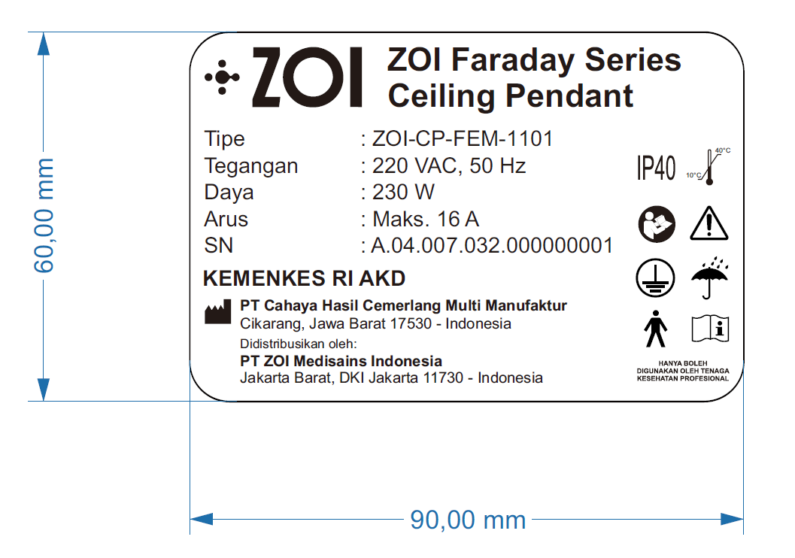

Gambar 1. Label Penandaan ZOI Faraday Series Ceiling Pendant Electric & Electromagnetic Single Arm For Anesthesia

1. **Kemasan**
   1. Wooden Box ZOI Faraday Series Ceiling Pendant Electric & Electromagnetic Single Arm For Anesthesia #1
      * Bahan : Kayu
      * Bentuk : Kotak
      * Warna : Natural/kayu/Coklat
      * Ukuran : 135 x 35 x 75 cm (p x l x t)

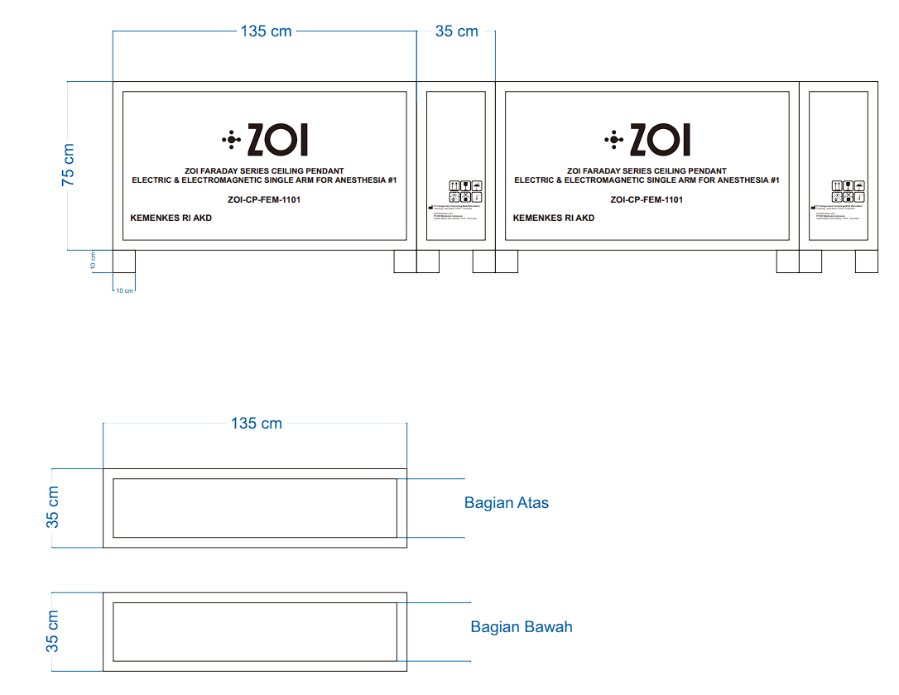

Gambar 2. Wooden Box ZOI Faraday Series Ceiling Pendant Electric & Electromagnetic Single Arm For Anesthesia #1

* 1. Wooden Box ZOI Faraday Series Ceiling Pendant Electric & Electromagnetic Single Arm For Anesthesia #2
     + Bahan : Kayu
     + Bentuk : Kotak
     + Warna : Natural/kayu/Coklat
     + Ukuran : 190 x 50 x 45 cm (p x l x t)

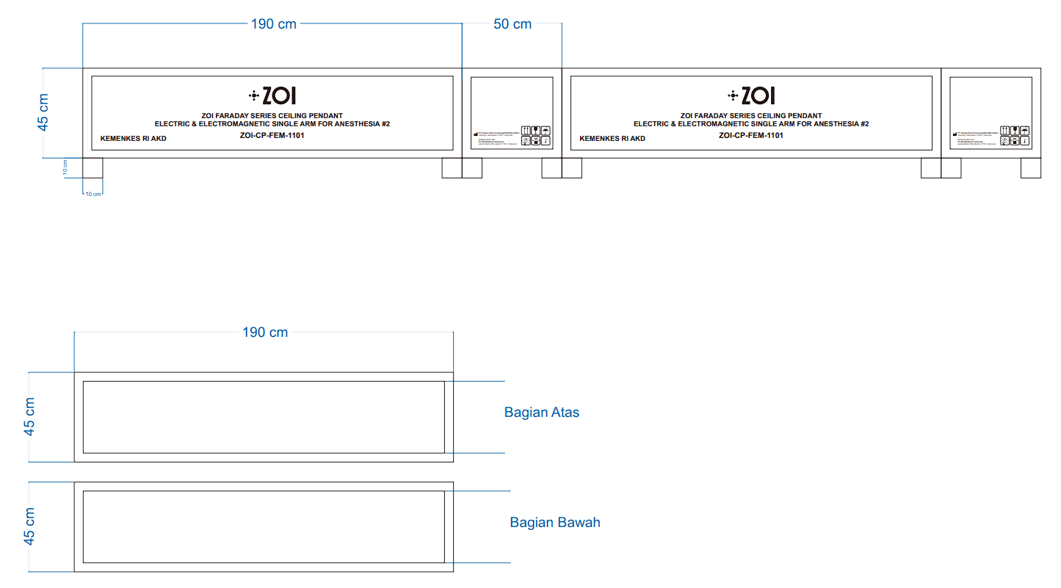

Gambar 3. Wooden Box ZOI Faraday Series Ceiling Pendant Electric & Electromagnetic Single Arm For Anesthesia #2